
Haydn Primary School Curriculum Overview – EYFS (F1)
2023-24
 | AUTUMN 1  5.9.23 - 20.10.23  (6 WEEKS, 3 DAYS) | AUTUMN 2  6.11.23 – 20.12.23  (6 WEEKS, 3 DAYS) | SPRING 1  4.1.24 – 9.2.24  (5 WEEKS, 2 DAYS) | SPRING 2  12.2.24 – 28.3.24  (6 WEEKS, 4 DAYS) | SUMMER 1  15.4.24 – 24.5.24  (6 WEEKS) | SUMMER 2  3.6.23 – 26.7.24  (8 WEEKS)
MAIN THEMES  PROJECT LAUNCH | Me and My Nursery | Festival Fun! | Winter and Keeping Warm | Looking after ourselves | Traditional Tales | Change and Grow
COMMUNICATION & LANGUAGE  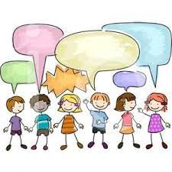 | Lovely Listening  Listen to and join in with stories, songs and songs. | Terrific Turn-taking  Listen to and follow short instructions  Participate in small group discussions about stories | Negotiating with friends.  Take part in pretend play, communicating and negotiating with their friends. | Confident Communication  Expressing likes and dislikes.  Talk in short sentences. | Calm conversations.  Start a conversation with an adult or a friend.  Participate in whole class discussions, offering their own ideas | Talk about the past.  Talk about familiar stories.  Share past events.  Link learning to experiences out of school.
PSED    PSHE Jigsaw scheme | Being in my world  Working together  Understanding my feelings  Sharing and kindness | Celebrating difference  Being special and unique  Making friends | Relationships  My family and friends  Calming strategies  Working together | Healthy me  Being active and healthy  Washing hands  Saying NO to strangers | Dreams  Keep trying when things get tricky  Feeling proud  Helping others | Changing me  Changing and growing  Moving to big school
FINE MOTOR  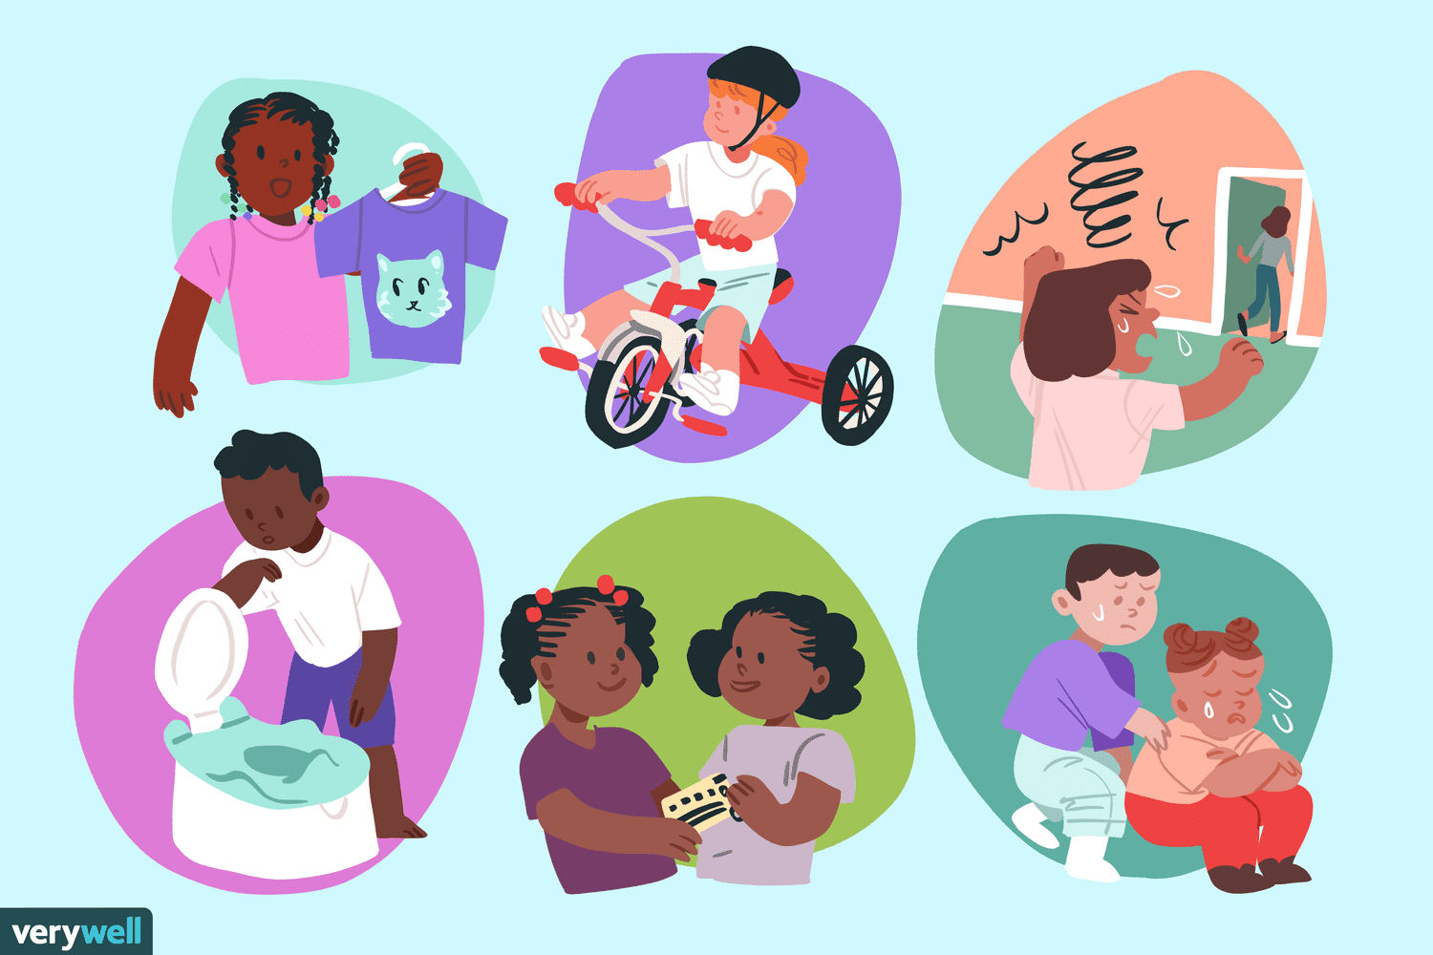 | Building and balancing.  Pencil control:- Mark making using tools such as chunky chalks, mark makers in sand etc, predominantly using fist grip. Handles tools with increasing control | Cutting and sticking.  Pencil control :- Mark making using tools such as chunky chalks, mark makers in sand etc, predominantly using fist grip. Handles tools with increasing control | Using tools for a purpose.  Pencil control :- Using mark makers with developing tripod grip and dominant hand to follow large pattern outlines Shows a dominant hand and can use the basis of a 3 finger pencil grip | Fix and fasten.  Pencil control :- Using mark makers with developing tripod grip and dominant hand to follow large pattern outlines Shows a dominant hand and can use the basis of a 3 finger pencil grip | Careful control.  Pencil control :- Using mark makers with developing tripod grip and dominant hand to form some letter shapes Shows a dominant hand and can use the basis of a 3 finger pencil grip | Wonderful writing.  Pencil control :- Using mark makers with developing tripod grip and dominant hand to form some letter shapes. Shows a dominant hand and can use the basis of a 3 finger pencil grip
GROSS MOTOR   | Use large-muscle movements to draw lines and circles and make marks  Continue to develop their movement, balancing, riding (scooters, trikes and bikes). | Skip, hop, stand on one leg and hold a pose for a game like musical statues. | Choose the right resources to carry out their own plan. For example, choosing a spade to enlarge a small hole they dug with a trowel. | Increasingly be able to use and remember sequences and patterns of movements which are related to music and rhythm. | Match their developing physical skills to tasks and activities in the setting. For example, they decide whether to crawl, walk or run across a plank, depending on its length and width. | Collaborate with others to manage large items, such as moving a long plank safely, carrying large hollow blocks.
LITERACY  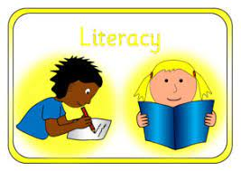 | Joining in with familiar rhymes and stories.  Writing:  Mark making using mark making tools in trays of sand etc. Using larger paintbrushes to paint with. Using chunky chalks on the ground outside. Manipulating play dough with variety of tools Draw some marks on paper, not always distinguishable | Joining in with familiar rhymes and stories.  Sequencing story events.  Recognise name  Begin to order letters in name.  Writing:  Mark making using mark makers such as chunky chalks, paintbrushes, pens Following large pattern templates Draw some marks on paper, not always distinguishable | Joining in with familiar rhymes and stories.  Sequencing story events.  Identify characters.  Recognise name  Order letters in name  Writing: Mark making using pens/ pencils/ chalks/ paintbrushes Follows large pattern outlines such as wavy lines or straight lines / can give meaning to the marks they make | Joining in with familiar rhymes and stories.  Sequencing story events.  Identify characters.  Recognise name  Order letters in name  Begin to write name  Writing: Mark making using pens/ pencils/ chalks/ paintbrushes Follows large pattern outlines such as wavy lines or straight lines / can give meaning to the marks they make | Joining in with familiar rhymes and stories.  Sequencing story events.  Identify characters.  Recognise name  Order letters in name  Write name  Writing: Use some of their print and letter knowledge in their early writing. For example: writing a pretend shopping list that starts at the top of the page; writing ‘m’ for mummy. | Joining in with familiar rhymes and stories.  Sequencing story events.  Identify characters.  Recognise name  Order letters in name  Write name  Write some sounds  Uses pens/ pencils/ paintbrushes form some letter shapes. Writes for a range of purposes i.e. shopping list, letter, a picture (not always using correct letters.)
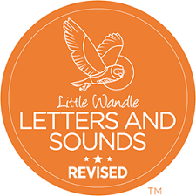  PHONICS | Listening and turn-taking games. | s a t p i n  Teach children to hear the same initial sound for words and names of objects. | m d g o c k e  Teach children to identify initial sounds of words and names of objects. Teach children to distinguish different sounds | u r h b f l j  Teach children to identify initial sounds of words and names of objects. Teach children to articulate sounds correctly – including playing with voice sounds. | v w y z qu ch  Teach children to identify initial sounds of words and names of objects. | ck x sh th ng nk  Teach children to identify initial sounds of words and names of objects.
MATHEMATICS  See MTP for more detail.  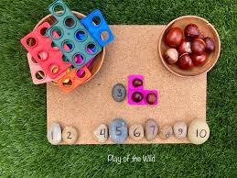 | - Counting and number rhymes.  Counting aloud to 5.  ‘Finger numbers’ to 3.  See and say some numerals to 3 e.g. when coming across a number in the environment  - Compare 2 groups | - Counting and number rhymes.  Join in with ‘one more’ and ‘one less’ Number songs e.g. 5 Little Speckle Frogs  Identify patterns in the environment, e.g. ‘pointy’, ‘spotty’, ‘blobs’  - Develop part-part whole knowledge  - Match 2 groups of the same quantity | Consistently recite numbers in order to 5  Know that the last number reached when counting a small set tells you how many there are in total (consistently with numbers to 5)  Say one number name for each item when counting sets of objects to 5  sort a set of objects into 2 groups | Link numerals to amounts: e.g. showing the right number of objects to match the numeral (to 3)  Begin to solve real world, practical mathematical problems with numbers up to 5 (one more than, one less than)  Know the whole is bigger than the parts  Subitise to 3 | Consistently recite numbers to 10  Consistently showing ‘finger numbers’ to 5 and sometimes beyond.  Counting a set of objects or pictures, accurately saying how many are in the set (consistently with numbers to 5 and then 10)  Subitise to 4  Part, part whole  Continue to explore 2D and 3D shapes; begin to select shapes appropriately | Compare quantities using language ‘more than’ ‘fewer than’  Identfy, continue and correct ABAB patterns  Confidently use language to make comparisons between objects relating to size, weight, length and capacity  Describe a sequence of events, using words such as ‘first’, ‘then’  Count between 5-10 presented objects using 1:2:1 correspondence
UNDERSTANDING OF THE WORLD   | Rosh Hashanah  Summer to Autumn seasonal changes.  Different homes | Festival of Light.  Helping Wildlife hibernate to survive winter.  Christmas. | Chinese New Year.  Winter to Spring seasonal changes. | Mother’s Day  Local community – Pudding Pantry | Spring to Summer seasonal changes.  Eid and Ramadan  Growing and changing | Seaside  Getting ready for big school
EXPRESSIVE ARTS & DESIGN  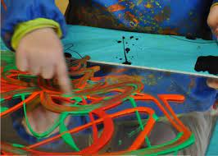 | Recognising colour  Exploring a range of tools  Music: | Manipulate dough in different ways  Music: Bells and shakers to support Christmas songs. | Drawing ourselves and our family  Exploring colour mixing  Music: | Beginning to weave  Printing with sponges and food  Music: | Developing our models  Music: | Arts Week!  Music:
CORE BOOKS  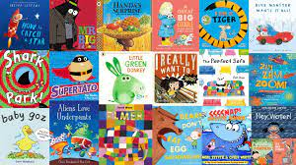 | Going on a Bear Hunt  Shark in the Park  Three Little Pigs  Pumpkin Soup | Pumpkin Soup  Story of Diwali  Owl Babies  Peace at Last  Owl and the Star  Nativity Story | One snowy night  Cuddly Duddly  Non-Fiction Polar Animals  Chinese Zodiac Story | Tiger Who Came to Tea  Handa’s Surprise  Goldilocks and the three bears  Dora’s Eggs  We’re going on an egg hunt | Ramadan stories  Gingerbread man  People who help us – Dr Ranj  Mrs Mopple’s Washing Line | The Very Hungry Caterpillar  Jack and Beanstalk  Smartest Giant in Town  Snail and Whale
Additional Enrichment Opportunities  (Trips/Visitors/Celebrations) | Barefoot sensory walk  Autumn Trail  Autumn crafts in wild garden | Christmas Song celebration with families – hot chocolate, biscuits and sing-along!  Diwali songs and celebration. | Winter Walk  Ice experiments  Visit from percy the parkkeeper | Mother’s day afternoon tea  Ramadan party!  Easter celebrations including egg hunt. | Father’s Day – special treat day (lawn games)  Fire engine visit  Teddy bear hospital – nursery own  Tiny Town Adventures! | Trip to orchard  End of year picnic with families  Plant a pot!  Sports day

