The Windows of Our World A Nottingham Schools Trust Art Project

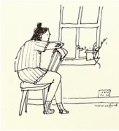

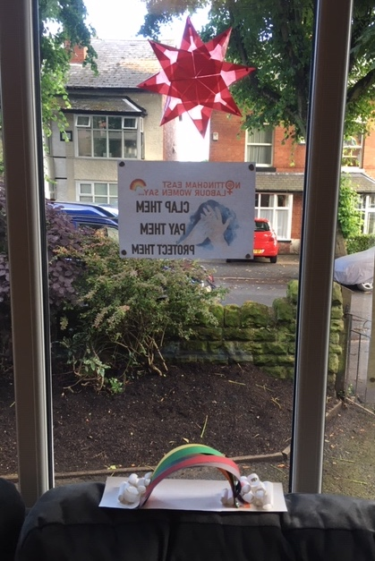

Reflecting on our time at home during COVID19 lockdown.

What we missed.

What we enjoyed.

What we will remember.

Nina Cosford SELF COMPANY

Everyday I look out of my window;

**I will remember the rainbows, the teddies, the sunshine, the rain and staying in.**

Draw, paint or photograph a picture of what would be in the window of **your** world.

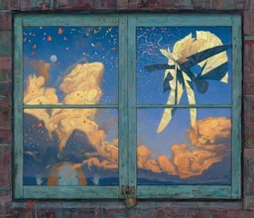

It could be:

The real view from your window

The view would you would like

Something you missed doing

Something you enjoyed doing

Something you will remember

Shaun Tan THE RED TREE

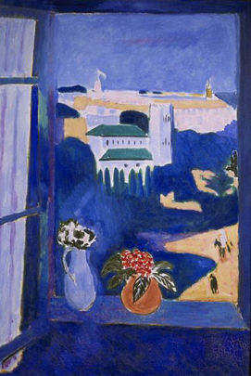

Octavia Bromell

Everyone sees the world through their own windows in their own way…create a window of your world and let us know what you remember from lockdown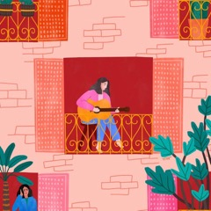.

Henri Matisse

Take a picture and we will display it on our website gallery <http://www.nottinghamschoolstrust.org.uk/>