
Haydn Primary School Curriculum Overview – EYFS F2
2024-25
 | AUTUMN 1  2.9.24- 18.10.24  (7 WEEKS) | AUTUMN 2  4.11.24 – 20.12.24  (7 WEEKS) | SPRING 1  6.1.25 – 14.2.25  (6 WEEKS) | SPRING 2  24.2.25 – 4.4.25  (6 WEEKS) | SUMMER 1  22.4.25 – 23.5.25  (4 WEEKS 3 DAYS) | SUMMER 2  2.6.25 – 25.7.25  (8 WEEKS)
MAIN THEMES  PROJECT LAUNCH | Magical Me! | Shining Bright! | Hot or cold? | Celebration time! | Once upon a time … | Out and about!
COMMUNICATION & LANGUAGE  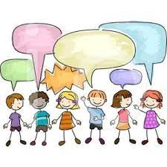 | Listen and talk about stories  Participate in small group discussions  Learn to listen carefully and understand why listening is important  To follow instructions  Talk to familiar adults  Vocabulary – words of the week relating to core text | Participate in whole class discussions, offering their own ideas  To begin to understand why and how questions  Respond to two-part instructions  Use new vocabulary throughout the day | Make comments about what they have heard and ask questions to clarify their understanding  To talk in sentences using conjunctions e.g. and, because  Vocabulary – Philosophy for children question each week  Engage in non-fiction books | Retell a story  Follow a story without pictures or props  Showcase work to class – standing up in front of peers to discuss what they have done | Offer explanations for why things might happen, making use of recently introduced vocabulary from various genres  Understand questions such as who, what, where, when, why and how  Use talk to organise, sequence and clarify thinking, feelings and ideas  Vocabulary – word of the day | Talk in sentences using past, present and future tenses  Talk to different adults in school
  PSED | Being me in my world  Develop class rules and understand why they have to be followed  Seek support of adults when needed  Gain confidence to speak to adults and peers | Celebrating difference  Have confidence to try new activities  Develop friendships  Work as part of a group | Dreams and goals  Begin to show resilience and perseverance in the face of a challenge  Take turns when playing games | Healthy me  Identify and name healthy foods  Understand the importance of healthy food choices | Relationships  Manage basic needs independently  Listen to the ideas of others and agree on a solution and compromise | Changing me  Show resilience and perseverance in the face of a challenge  Show a ‘can do’ attitude  Have strong friendships
PHYSICAL DEVELOPMENT  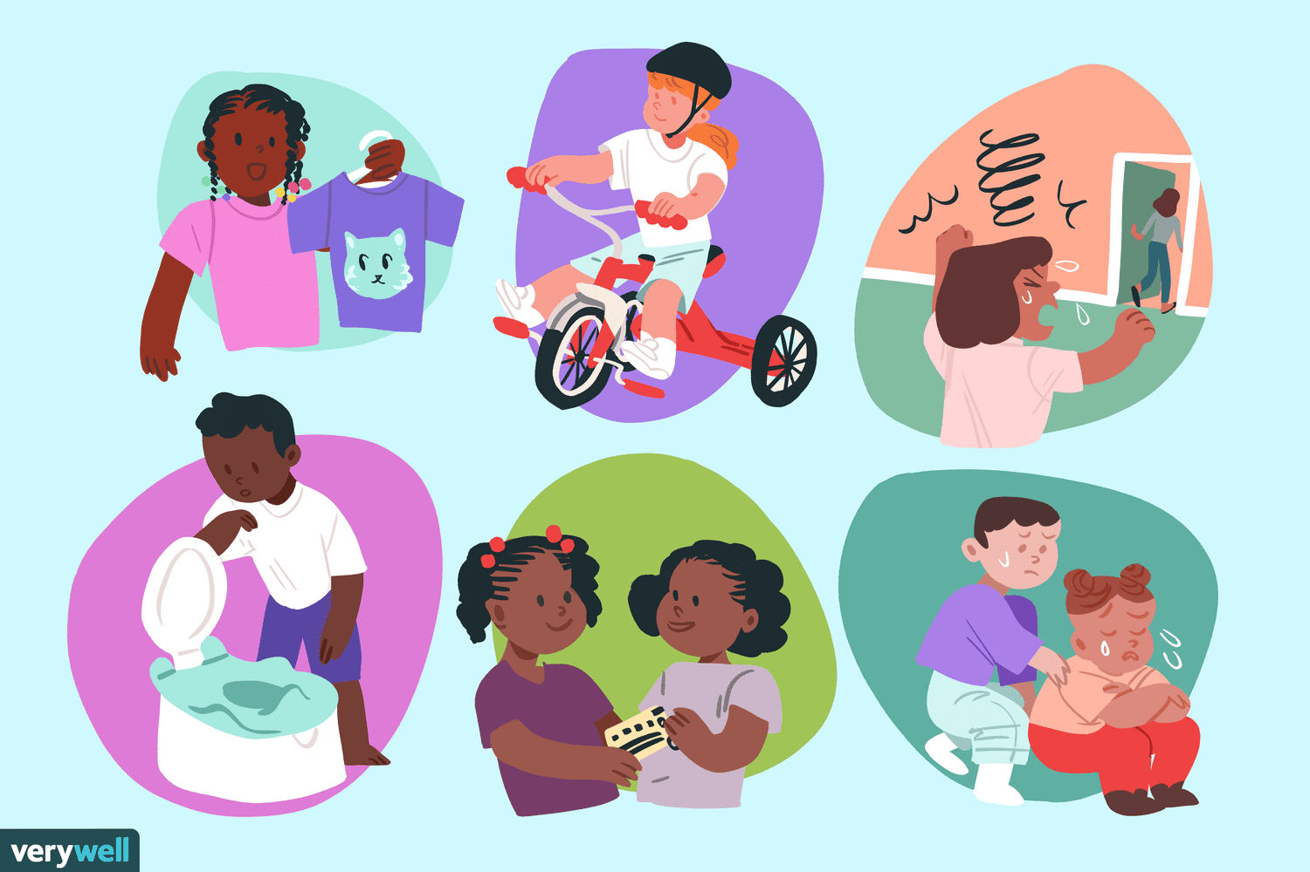 | To put coat on independently  Use one-handed tools and equipment more confidently  Wash hands independently  Use a dominant hand  Hold scissors correctly and cut snips in paper  Copy letters  Paint shapes using thick brushes | Develop tripod grip when using mark making tools  Hold scissors correctly and cut along a straight and zig zag  Draw lines, circles and shapes  Write taught letters using correct formation  Begin to retrace and vertical lines  Hold a knife correctly and use to cut food | Use tripod grip when using mark making tools  Use a range of small tools, including scissors, paintbrushes and cutlery  Practise doing up a zip on their coat/fastening buttons  Hold scissors correctly and cut a curved line | To use a range of tools competently, safely and confidently  Write letters using correct formation and control size of letters  Use scissors to cut out large shapes | Begin to show accuracy and care when drawing  Use scissors to cut out small shapes  Paint using thin brushes | Create drawings with detail  Write letters using correct formation and form them the correct size
PE (F2)  REAL PE Programme   | Unit 2 – Play with others | Unit 3 – Follow rules | Unit 4 – Observe and copy | Unit 5 – Move in different ways | Unit 6 – Exercise and good health | Recap previously taught skills
LITERACY  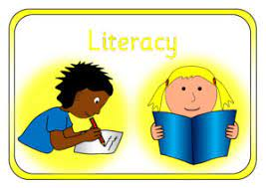 | Oral composition assessment  Name writing  Write initial sounds  Write a CVC words using taught sounds  Begin to write captions  Story mapping  Read a phase 2 book  Recognise name  Use pictures to tell a story  Hold a book correctly – find title, author and turn one page at a time  Practise segmenting CVC words  Copy writing name | Write simple sentences  (I can see)  Learn to use a grapheme mat  Write captions using taught sounds  Read simple sentences  Oral composition assessment  Practise letter formation  Write a list  Read a phase 2 book  Begin to answer comprehension questions about a story  Practise using prosody when reading  Begin to use finger spaces | Speech bubbles  Complete a story grid  Learn to use a word bank  Write a simple sentence by composing a sentence orally before writing it  Read a phase 3 book  Predict what might happen in a story  Suggest how a story might end  Explore non-fiction books  Spell some tricky words correctly  Understand sentences start with a capital letter and end with a full stop | Write simple phrases  Write beginning, middle and end of a story  Read short captions from a familiar text  Read a variety of tricky words matched to LW  Read a phase 3 book  Confidently retell a story  Talk about the characters in stories  Begin to write sentences with a capital letter, finger spaces and full stop | Write a familiar story with recognisable letters, most of which are correctly formed (T4W)  Begin to form lower case letters in the right direction  Read a phase 4 book  Answer comprehension questions confidently  Begin to write longer words phonetically | Read a complex sentence  Write their own story  To use the correct text type when writing for a purpose e.g. making a list for the shop  Reread writing to ensure it makes sense  Read a phase 4 book  Learn that information can be retrieved from books
PHONICS  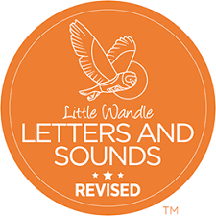 | Phase 2 graphemes  s a t p i n m d g o c k ck e u r h b f l  Tricky words  is I the | Phase 2 graphemes  ff ll ss j v w x y z zz qu ch sh th ng nk  Tricky words  Put pull full as and has his her go no to into she push he of we me be | Phase 3 graphemes  ai ee igh oa oo oo ar or ur ow oi ear air er  Tricky words  was you they my by all are sure pure | Phase 3 graphemes  Review  Tricky words  Review | Phase 4  Shorter vowels with adjacent consonants  Tricky words  said so have like some come love do were here little says there when what one out today | Phase 4  Phase 3 long vowel graphemes with adjacent consonants  Tricky words  Review
MATHEMATICS  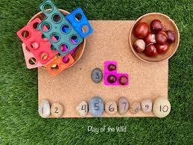 | Match, sort and compare  Talk about measure and patterns  It’s me 1, 2, 3 | It’s me 1, 2, 3  Circles and triangles  1 ,2, 3, 4, 5  Shapes with 4 sides | Alive in 5  Mass and capacity  Length, height and time | Building 9 and 10  Explore 3D shapes | To 20 and beyond  How many now?  Manipulate, compose and decompose | Sharing and grouping  Visualise, build and map  Make connections
UNDERSTANDING OF THE WORLD   | Seasonal change  Nocturnal animals  Maps | Diwali  Toys – past and present  Christmas | Changing states on matter – ice  Chinese New Year  Similarities and differences – England and polar regions | Ramadam and Eid  Easter  Gruffalo crumble | Different occupations | All about me – past and present  Life cycles: caterpillars – butterflies  Baby – adult
EXPRESSIVE ARTS & DESIGN  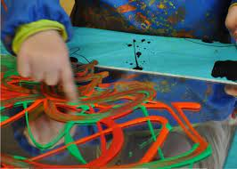 | Food preparation – bear toast/making bread  Making creations using junk boxes, construction (small and large), deconstructed role play – children to talk about what they made, why and how they could improve it | Transient art – fireworks  Printing – seasonal vegetables (link to artist)  Perform songs - Christmas performance  Recount narratives – The Christmas Story | Food preparation – hot chocolate  Making bird feeders  Lowry pictures | Food preparation – cakes for café  Make Gruffalo puppets  Build houses for the Three Little Pigs  Design an Easter egg | Perform songs/poems – Father’s Day show  Create a new cloak for Little Red Riding Hood (link to artist) | Arts week (link to artist)  Invent/adapt stories using a repertoire of stories to inspire them
CORE BOOKS  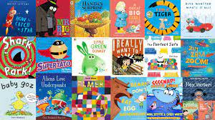 | We’re going on a bear hunt  The Little Red Hen  Leaf Man/Tree | Owl Babies  The Gingerbread Man  The Christmas Story | One Snowy Night  Oliver Jeffers –  Lost and Found  How to catch a star  Up and Down  The Way Back Home | The Gruffalo  Julia Donaldson stories  The Three Little Pigs  We’re going on an Egg Hunt | Little Red Riding Hood  Goldilocks  People who help us non-fiction books | Oliver’s vegetable  Handa’s Surprise  Jack and the Beanstalk  The Very Hungry Caterpillar
Additional Enrichment Opportunities  (Trips/Visitors/Celebrations) | Greens Windmill – making bread  Woodthorpe Park | Lakeside Arts – The Storm Whale  Christmas  Diwali | Winter walk | Mother’s Day – café  St Ann’s Orchard  Easter egg hunt  Visit from the church  World Book Day | Father’s Day – special singing concert  Fire engine | Brackenhurst Education Centre  End of year celebration (picnic/graduation)

